**Introduction to Modeling**

A model is a set of rules, formulas, or equations that can be used to predict an outcome based on a set of input fields or variables. For example, a financial institution might use a model to predict whether loan applicants are likely to be good or bad risks, based on information that is already known about past applicants.

The ability to predict an outcome is the central goal of predictive analytics, and understanding the modeling process is the key to using IBM® SPSS® Modeler.

*Figure 1. A simple decision tree model*

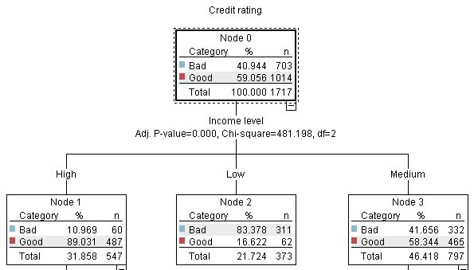

This example uses a **decision tree** model, which classifies records (and predicts a response) using a series of decision rules, for example:

IF income = Medium

AND cards <5

THEN -> 'Good'

While this example uses a CHAID (Chi-squared Automatic Interaction Detection) model, it is intended as a general introduction, and most of the concepts apply broadly to other modeling types in IBM SPSS Modeler.

To understand any model, you first need to understand the data that go into it. The data in this example contain information about the customers of a bank. The following fields are used:

| **Field name** | **Description** |
| --- | --- |
| Credit_rating | Credit rating: 0=Bad, 1=Good, 9=missing values |
| Age | Age in years |
| Income | Income level: 1=Low, 2=Medium, 3=High |
| Credit_cards | Number of credit cards held: 1=Less than five, 2=Five or more |
| Education | Level of education: 1=High school, 2=College |
| Car_loans | Number of car loans taken out: 1=None or one, 2=More than two |

The bank maintains a database of historical information on customers who have taken out loans with the bank, including whether or not they repaid the loans (Credit rating = Good) or defaulted (Credit rating = Bad). Using this existing data, the bank wants to build a model that will enable them to predict how likely future loan applicants are to default on the loan.

Using a decision tree model, you can analyze the characteristics of the two groups of customers and predict the likelihood of loan defaults.

This example uses the stream named *modelingintro.str*, available in the *Demos* folder under the *streams*subfolder. The data file is *tree_credit.sav*. See the topic [Demos Folder](http://127.0.0.1:54857/help/topic/com.ibm.spss.modeler.tutorial/clementine/entities/demo_folder_intro.htm#demo_folder_intro) for more information.

Let's take a look at the stream.

1. Choose the following from the main menu:

**File** > **Open Stream**

1. Click the gold nugget icon on the toolbar of the Open dialog box and choose the Demos folder.
2. Double-click the *streams* folder.
3. Double-click the file named *modelingintro.str*.

**Building the Stream**

*Figure 1. Modeling stream*

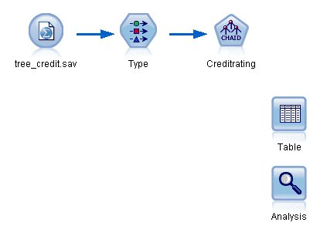

To build a stream that will create a model, we need at least three elements:

* A source node that reads in data from some external source, in this case an IBM® SPSS® Statistics data file.
* A source or Type node that specifies field properties, such as measurement level (the type of data that the field contains), and the role of each field as a target or input in modeling.
* A modeling node that generates a model nugget when the stream is run.

In this example, we’re using a CHAID modeling node. CHAID, or Chi-squared Automatic Interaction Detection, is a classification method that builds decision trees by using a particular type of statistics known as chi-square statistics to work out the best places to make the splits in the decision tree.

If measurement levels are specified in the source node, the separate Type node can be eliminated. Functionally, the result is the same.

This stream also has Table and Analysis nodes that will be used to view the scoring results after the model nugget has been created and added to the stream.

The Statistics File source node reads data in IBM SPSS Statistics format from the *tree_credit.sav* data file, which is installed in the *Demos* folder. (A special variable named *$CLEO_DEMOS* is used to reference this folder under the current IBM SPSS Modeler installation. This ensures the path will be valid regardless of the current installation folder or version.)

*Figure 2. Reading data with a Statistics File source node*

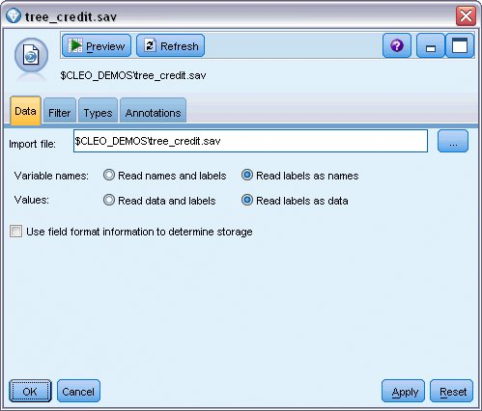

The Type node specifies the **measurement level** for each field. The measurement level is a category that indicates the type of data in the field. Our source data file uses three different measurement levels.

A **Continuous** field (such as the *Age* field) contains continuous numeric values, while a **Nominal** field (such as the *Credit rating* field) has two or more distinct values, for example *Bad*, *Good*, or *No credit history*. An **Ordinal** field (such as the *Income level* field) describes data with multiple distinct values that have an inherent order—in this case *Low*, *Medium* and *High*.

*Figure 3. Setting the target and input fields with the Type node*

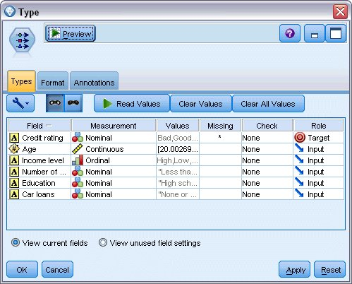

For each field, the Type node also specifies a **role**, to indicate the part that each field plays in modeling. The role is set to *Target* for the field *Credit rating*, which is the field that indicates whether or not a given customer defaulted on the loan. This is the **target**, or the field for which we want to predict the value.

Role is set to *Input* for the other fields. Input fields are sometimes known as **predictors**, or fields whose values are used by the modeling algorithm to predict the value of the target field.

The CHAID modeling node generates the model.

On the Fields tab in the modeling node, the option **Use predefined roles** is selected, which means the target and inputs will be used as specified in the Type node. We could change the field roles at this point, but for this example we'll use them as they are.

1. Click the Build Options tab.

*Figure 4. CHAID modeling node, Fields tab*

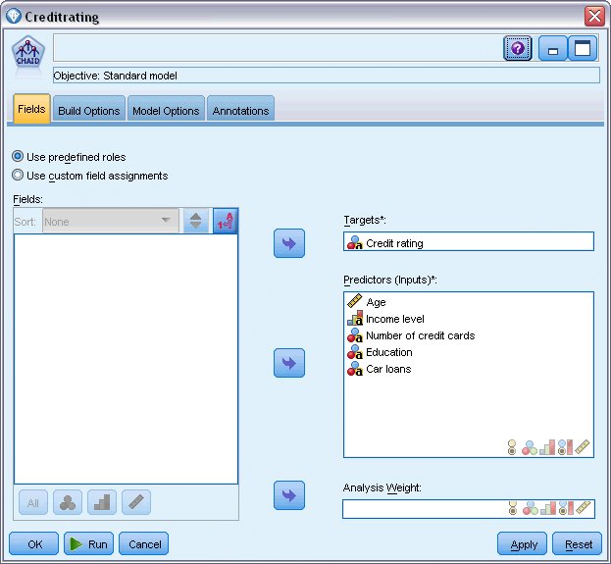

Here there are several options where we could specify the kind of model we want to build.

We want a brand-new model, so we'll use the default option **Build new model**.

We also just want a single, standard decision tree model without any enhancements, so we'll also leave the default objective option **Build a single tree**.

While we can optionally launch an interactive modeling session that allows us to fine-tune the model, this example simply generates a model using the default mode setting **Generate model**.

*Figure 5. CHAID modeling node, Build Options tab*

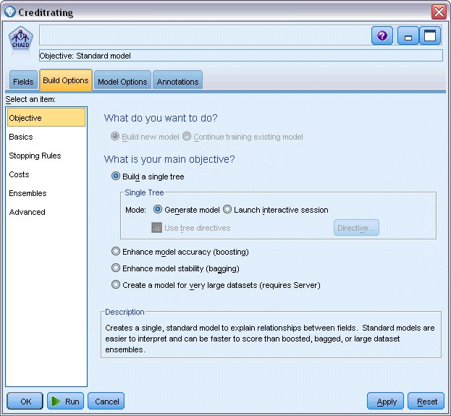

For this example, we want to keep the tree fairly simple, so we'll limit the tree growth by raising the minimum number of cases for parent and child nodes.

1. On the Build Options tab, select **Stopping Rules** from the navigator pane on the left.
2. Select the **Use absolute value** option.
3. Set **Minimum records in parent branch** to 400.
4. Set **Minimum records in child branch** to 200.

*Figure 6. Setting the stopping criteria for decision tree building*

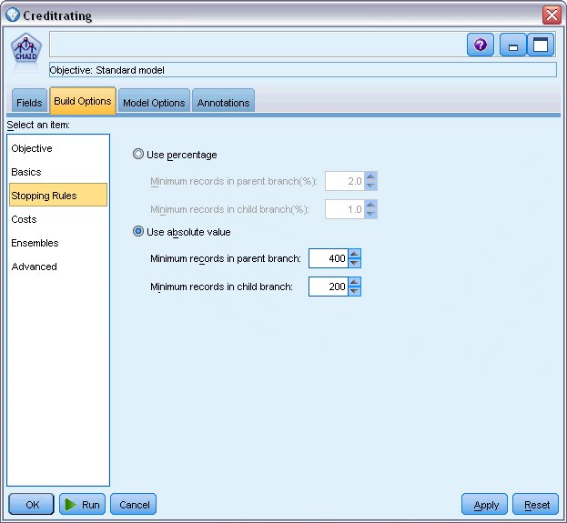

We can use all the other default options for this example, so click **Run** to create the model. (Alternatively, right-click on the node and choose **Run** from the context menu, or select the node and choose **Run** from the Tools menu.)

# Browsing the Model

When execution completes, the model nugget is added to the Models palette in the upper right corner of the application window, and is also placed on the stream canvas with a link to the modeling node from which it was created. To view the model details, right-click on the model nugget and choose **Browse** (on the models palette) or **Edit** (on the canvas).

*Figure 1. Models palette*

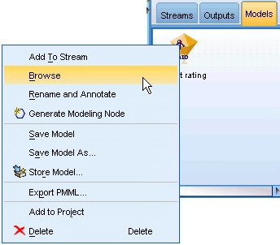

In the case of the CHAID nugget, the Model tab displays the details in the form of a rule set--essentially a series of rules that can be used to assign individual records to child nodes based on the values of different input fields.

*Figure 2. CHAID model nugget, rule set*

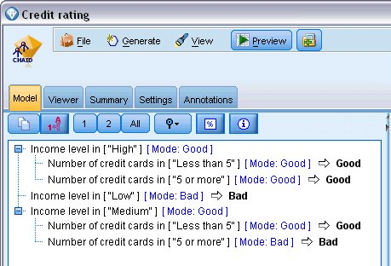

For each decision tree terminal node--meaning those tree nodes that are not split further--a prediction of Good or Bad is returned. In each case the prediction is determined by the **mode**, or most common response, for records that fall within that node.

To the right of the rule set, the Model tab displays the Predictor Importance chart, which shows the relative importance of each predictor in estimating the model. From this we can see that Income level is easily the most significant in this case, and that the only other significant factor is Number of credit cards.

*Figure 3. Predictor Importance chart*

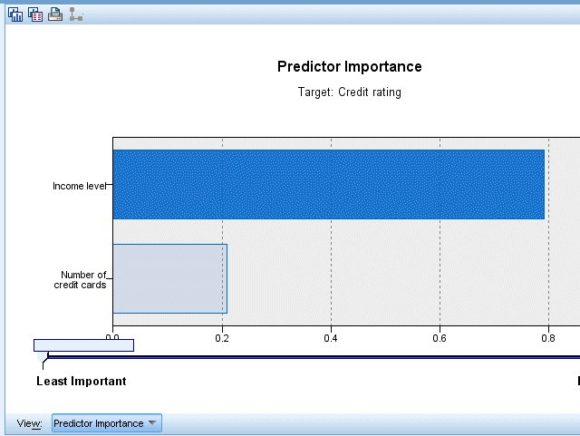

The Viewer tab in the model nugget displays the same model in the form of a tree, with a node at each decision point. Use the Zoom controls on the toolbar to zoom in on a specific node or zoom out to see the more of the tree.

*Figure 4. Viewer tab in the model nugget, with zoom out selected*

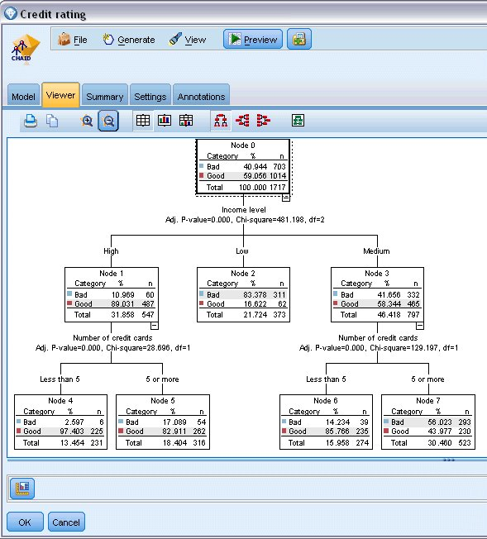

Looking at the upper part of the tree, the first node (Node 0) gives us a summary for all the records in the data set. Just over 40% of the cases in the data set are classified as a bad risk. This is quite a high proportion, so let’s see if the tree can give us any clues as to what factors might be responsible.

We can see that the first split is by Income level. Records where the income level is in the Low category are assigned to Node 2, and it’s no surprise to see that this category contains the highest percentage of loan defaulters. Clearly lending to customers in this category carries a high risk.

However, 16% of the customers in this category actually didn’t default, so the prediction won’t always be correct. No model can feasibly predict every response, but a good model should allow us to predict the most likely response for each record based on the available data.

In the same way, if we look at the high income customers (Node 1), we see that the vast majority (89%) are a good risk. But more than 1 in 10 of these customers has also defaulted. Can we refine our lending criteria to minimize the risk here?

Notice how the model has divided these customers into two sub-categories (Nodes 4 and 5), based on the number of credit cards held. For high-income customers, if we lend only to those with fewer than 5 credit cards, we can increase our success rate from 89% to 97%--an even more satisfactory outcome.

*Figure 5. Tree view of high-income customers*

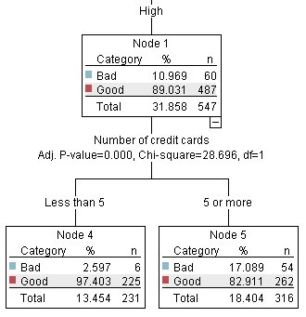

But what about those customers in the Medium income category (Node 3)? They’re much more evenly divided between Good and Bad ratings.

Again, the sub-categories (Nodes 6 and 7 in this case) can help us. This time, lending only to those medium-income customers with fewer than 5 credit cards increases the percentage of Good ratings from 58% to 85%, a significant improvement.

*Figure 6. Tree view of medium-income customers*

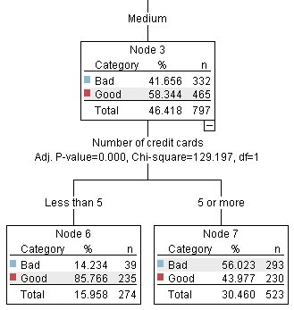

So, we’ve learnt that every record that is input to this model will be assigned to a specific node, and assigned a prediction of Good or Bad based on the most common response for that node.

This process of assigning predictions to individual records is known as **scoring**. By scoring the same records used to estimate the model, we can evaluate how accurately it performs on the training data—the data for which we know the outcome. Let’s look at how to do this.

**Evaluating the Model**

We've been browsing the model to understand how scoring works. But to evaluate *how accurately* it works, we need to score some records and compare the responses predicted by the model to the actual results. We're going to score the same records that were used to estimate the model, allowing us to compare the observed and predicted responses.

*Figure 1. Attaching the model nugget to output nodes for model evaluation*

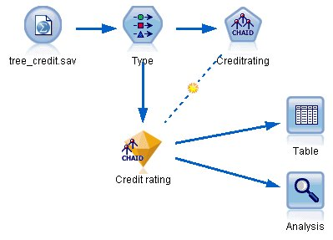

1. To see the scores or predictions, attach the Table node to the model nugget, double-click the Table node and click **Run**.

The table displays the predicted scores in a field named *$R-Credit rating*, which was created by the model. We can compare these values to the original *Credit rating* field that contains the actual responses.

By convention, the names of the fields generated during scoring are based on the target field, but with a standard prefix. Prefixes *$G* and *$GE* are generated by the Generalized Linear Model, *$R* is the prefix used for the prediction generated by the CHAID model in this case, *$RC* is for confidence values, *$X* is typically generated by using an ensemble, and *$XR*, *$XS*, and *$XF* are used as prefixes in cases where the target field is a Continuous, Categorical, Set, or Flag field, respectively. Different model types use different sets of prefixes. A **confidence value** is the model’s own estimation, on a scale from 0.0 to 1.0, of how accurate each predicted value is.

*Figure 2. Table showing generated scores and confidence values*

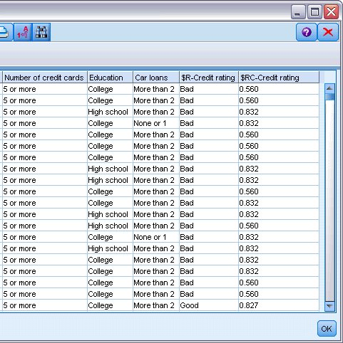

As expected, the predicted value matches the actual responses for many records but not all. The reason for this is that each CHAID terminal node has a mix of responses. The prediction matches the *most common* one, but will be wrong for all the others in that node. (Recall the 16% minority of low-income customers who did not default.)

To avoid this, we could continue splitting the tree into smaller and smaller branches, until every node was 100% pure—all *Good* or *Bad* with no mixed responses. But such a model would be extremely complicated and would probably not generalize well to other datasets.

To find out exactly how many predictions are correct, we could read through the table and tally the number of records where the value of the predicted field *$R-Credit rating* matches the value of *Credit rating*. Fortunately, there’s a much easier way--we can use an Analysis node, which does this automatically.

1. Connect the model nugget to the Analysis node.
2. Double-click the Analysis node and click **Run**.

*Figure 3. Attaching an Analysis node*



The analysis shows that for 1899 out of 2464 records--over 77%--the value predicted by the model matched the actual response.

*Figure 4. Analysis results comparing observed and predicted responses*

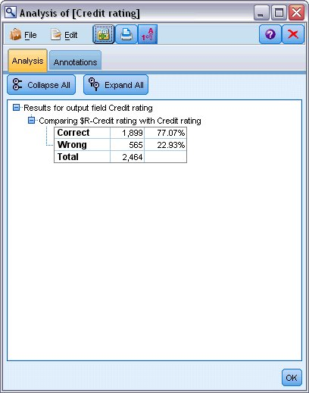

This result is limited by the fact that the records being scored are the same ones used to estimate the model. In a real situation, you could use a Partition node to split the data into separate samples for training and evaluation.

By using one sample partition to generate the model and another sample to test it, you can get a much better indication of how well it will generalize to other datasets.

The Analysis node allows us to test the model against records for which we already know the actual result. The next stage illustrates how we can use the model to score records for which we don't know the outcome. For example, this might include people who are not currently customers of the bank, but who are prospective targets for a promotional mailing.

# Scoring Records

Earlier, we scored the same records used to estimate the model in order to evaluate how accurate the model was. Now we're going to see how to score a different set of records from the ones used to create the model. This is the goal of modeling with a target field: Study records for which you know the outcome, to identify patterns that will allow you to predict outcomes you don't yet know.

*Figure 1. Attaching new data for scoring*

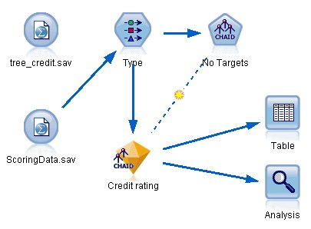

You could update the Statistics File source node to point to a different data file, or you could add a new source node that reads in the data you want to score. Either way, the new dataset must contain the same input fields used by the model (Age, Income level, Education and so on) but not the target field Credit rating.

Alternatively, you could add the model nugget to any stream that includes the expected input fields. Whether read from a file or a database, the source type doesn't matter as long as the field names and types match those used by the model.

You could also save the model nugget as a separate file, export the model in PMML format for use with other applications that support this format, or store the model in an IBM® SPSS® Collaboration and Deployment Services repository, which offers enterprise-wide deployment, scoring, and management of models.

Regardless of the infrastructure used, the model itself works in the same way

# Summary

This example demonstrates the basic steps for creating, evaluating, and scoring a model.

* The modeling node estimates the model by studying records for which the outcome is known, and creates a model nugget. This is sometimes referred to as training the model.
* The model nugget can be added to any stream with the expected fields to score records. By scoring the records for which you already know the outcome (such as existing customers), you can evaluate how well it performs.
* Once you are satisfied that the model performs acceptably well, you can score new data (such as prospective customers) to predict how they will respond.
* The data used to train or estimate the model may be referred to as the analytical or historical data; the scoring data may also be referred to as the operational data.